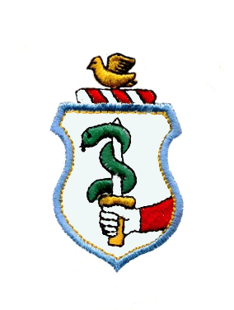
www.mullabrackgfc.com

Child/Young Person Registration Form (2 pages)

Name of Young Person:____________________________________________________

Seoladh/Address: ________________________________________________

________________________________________________________________

Date of Birth: Day Month Year (e.g. 06 02 90) ____________________________________

I hereby apply to: O’Donobhain Rossa, Mullabrack GFC Club for Membership of the above Club and Youth Membership of Cumann Lúthchleas Gael (The Gaelic Athletic Association)

I subscribe to and undertake to further the aims and objectives of the Club and of Cumann Lúthchleas Gael (The Gaelic Athletic Association), and to abide by its Rules, and I attach herewith the appropriate membership fee of £20.

Data Protection / GDPR It is necessary for O’Donnabhain Rossa Mullabrack GFC (“the Club”) to collect and record certain personal data relating to each member, including the member’s name, address, telephone number and date of birth. The data about each member shall be provided to the GAA via the Servasport website for registration purposes, and to the Armagh County Board if requested. It is the GAA that controls any data provided through servasport. The system will be used for management and administration purposes only. Any party receiving the information shall not use it for commercial purposes or release it to any party without prior approval. The Club wishes to ensure that each of its members (for the purposes of applicable data protection legislation) explicitly and unambiguously consents to the processing of personal data by the Club in conjunction with its ordinary business. Therefore, the member’s parent or guardian should confirm the following: I consent to the use of the player’s personal details as set out above and for such purposes as the GAA considers reasonable and appropriate (including those activities detailed above). Each member has the right to request in writing a copy of any personal data about themselves which is held and have amended any personal data which is incorrect, incomplete or misleading.

Yes No (please circle)

Injury/Illness/Disability/Medication I understand in the event of an injury or illness that all reasonable steps will be made to contact me by signing this form I allow the Coaches/First Aiders to deal with the injury/illness appropriately.

Yes No (please circle)

Photographs: By signing this form I give permission for Mullabrack GFC, Lissummin GFC and Clady GFC individually or amalgamated as ‘Shamrocks’ to use photographs of my child for promotional and/or reporting purposes

Yes No (please circle)

(see next page)

Club Communication. Check this box if you DO NOT want text messages and emails from coaches or the club 

Parent(s)/Guardian(s), on behalf of the above named:-

We/I consent to the above Application and to undertakings given by the

Sínithe/Signed:_______________________________ (Parent/Guardian) Dáta__________

Print Name: _______________________________________________________________

Preferred Contact Number: ___________________________________________________

Email address: ______________________________________________________________

For Official Use only:

Youth Membership Application approved by Club Executive on Dáta ____________________

Sinithe: __________________________________________________________ Club Runaí.

Registered in Central Membership Database on ____________________________________

Membership Identification Number: ______________________________________________

